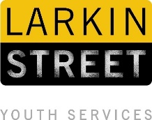
Media Contact:
Veronica Pastore
vpastore@larkinstreetyouth.org
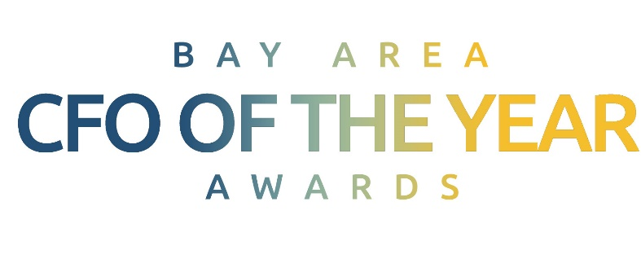
(415) 673.0911 ext. 305

Patricia E. Yarrington of Chevron Corporation selected for
Bay Area CFO of the Year Lifetime Achievement Award
13th annual CFO of the Year Awards recognizes area CFOs;
proceeds from the event benefit Larkin Street Youth Services

FOR IMMEDIATE RELEASE

San Francisco [February 22, 2018] – The independent selection panel of the 13th Annual Bay Area CFO of the Year Awards is proud to announce their 2018 Hall of Fame Lifetime Achievement Award winner: Patricia E. (Pat) Yarrington, Vice President and Chief Financial Officer of the Chevron Corporation. The Bay Area CFO of the Year Awards will be held at 6 p.m. on Thurs., June 7 at the Hyatt Regency San Francisco (5 Embarcadero Center). Tickets are $375 and include a cocktail reception, dinner, awards ceremony and post-event networking, and will be available for purchase at cfoawards.org in April.

The awards dinner is attended by more than 500 Bay Area business executives and community leaders and has raised over $5 million since its inception. All proceeds benefit Larkin Street Youth Services, the leading provider of housing, health services, job placement and more to young people experiencing homelessness in San Francisco.

The Hall of Fame Lifetime Achievement Award is given to a current or former CFO of a public or private company whose contribution has significantly and uniquely impacted the greater Bay Area business community over the course of his or her career.
“I am both flattered and honored to receive this recognition,” said Ms. Yarrington. “The true recognition, of course, belongs to the men and women of Larkin Street Youth Services, who work tirelessly to provide hope and tangible assistance to our at-risk Bay Area youth. Through their efforts, the team at Larkin Street is making a real difference for young people experiencing homelessness in our community. It’s deeply gratifying to support such a noble organization as they work to improve the lives of so many.”
Ms. Yarrington is Vice President and Chief Financial Officer of Chevron Corporation, a position she has held since 2009. She is responsible for comptroller, tax, treasury, audit and investor relations activities corporatewide. Serving on the San Francisco Federal Reserve’s board of directors from 2009 to 2014, she also became its chairman in 2013 and 2014. Yarrington joined Chevron in 1980 as a financial analyst. She earned a bachelor’s degree in political science from Pomona College in 1977 and a master’s degree in business administration from the Kellogg School of Management at Northwestern University in 1979.

In March, finalists in additional categories including public company, non-public company, emerging company, and nonprofit organization will be announced. This year’s selection panel is comprised of business and academic leaders including Alison Davis, Managing Partner, Fifth Era, Board Member: Royal Bank of Scotland, Diamond Foods, Fiserv, Unisys, and Ooma; Mary Huss, Publisher, San Francisco Business Times; Sharon McCollam, Winner, 2012 Hall of Fame Lifetime Achievement Award, Former Chief Administrative Officer and Chief Financial Officer, Best Buy; Byron Pollitt, Winner, 2013 Hall of Fame Lifetime Achievement Award, Retired Executive Vice President and Chief Financial Officer, Visa; and Richard Rosenberg, Retired Chief Executive Officer, Bank of America.

The Bay Area CFO of the Year Awards is presented by Larkin Street Youth Services, in partnership with the San Francisco Business Times, and title sponsors Deloitte and Marsh & McLennan Agency.

Business attire is recommended. To sponsor the Bay Area CFO of the Year Awards or for more information, visit cfoawards.org or call at (415) 673-0911 ext 306.

Bay Area CFO of the Year Awards: 6 p.m., Thurs., June 7, Hyatt Regency San Francisco, 5 Embarcadero Center, 673-0911 ext 306 or cfoawards.org, $375.

Please see attached for high-res photography, courtesy Chevron Corporation.

About The Bay Area CFO of the Year Awards
Now in its 13th year, The Bay Area CFO of the Year Awards event is a partnership between the San Francisco Business Times and Larkin Street Youth Services recognizing outstanding CFOs in the Bay Area. The event has raised over $5 million to benefit Larkin Street Youth Services and the homeless youth they serve. Learn more at cfoawards.org

About Larkin Street Youth Services
Larkin Street Youth Services is an internationally recognized leader in providing effective housing, education, employment and health services to at-risk, homeless and runaway youth. Larkin Street reaches ages 12 to 24 across San Francisco and has served over 75,000 homeless and at-risk youth since 1984.

Three out of four youth who complete the full range of Larkin Street programs successfully exit homelessness permanently. Larkin Street is at the forefront, working at the local, state and federal levels to create the circumstances necessary to make instances of youth homelessness rare, brief and non-recurring.

For every dollar invested in homeless youth, society sees $8 in social benefits or saved costs.

Learn more at larkinstreetyouth.org

###

