PR:ORLANDO WORLD CENTER:Logos:Hotel Logos:New Hotel Logo 2014:MCOWC_Logos_Single Line:MCOWC_Logos:EPS Vector:MCOWC_Primary_CMYK.eps**CONTACT**: Orlando World Center Marriott

8701 World Center Drive, Orlando, Florida 32821 USA

+1 407-239-4200 <https://www.marriott.com/hotels/travel/mcowc-orlando-world-center-marriott/>

**World’s First Hycube™ Hydroponic Production System Is Launched at Orlando World Center Marriott**

*Innovative technology and structure changes how produce will be sourced by hotels and restaurants*

**Orlando, Florida** **– May 14, 2018** – Eco Convergence Group, Inc. (ECG) unveiled the first HyCube™ modular hydroponic vegetable production system at Orlando World Center Marriott. The HyCube’s data-driven, precisely controlled, patent-pending hydroponic system is constructed in an illuminated modern structure next to the hotel’s main kitchen. Orlando World Center Marriott is the first hotelier to utilize the revolutionary HyCube growing system, growing produce for its nine dining outlets and 450,000 sq. ft. of [unique meeting and event space](https://www.marriott.com/hotels/event-planning/business-meeting/mcowc-orlando-world-center-marriott/).

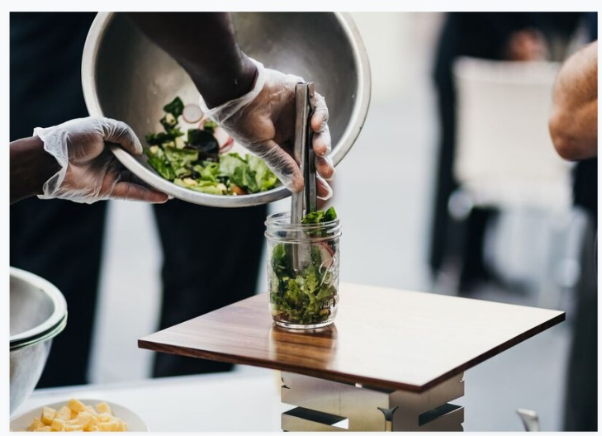

The hotel’s Executive Chef Eric Martinez and his culinary team will have a constant bounty of fresh, healthy produce, such as lettuce, baby spinach, herbs and edible flowers, all grown from organic, non-GMO seeds. The innovative production method inspired techniques for precise control of the micro-environment, including air and water quality, temperature and humidity, light conditions and nutrients. This allows for a steady yield of crisp, flavorful and nutritious produce without seasonal and regional limitations. Additionally, when compared to traditional farming, the HyCube consumes up to 90 percent less water and will reduce crop cycle by 20 percent without the use of harmful chemicals. Plant extracts will be used to create fresh green and probiotic drinks, and the water filtration system will provide purified water that will be bottled and offered in the Central Pantry, a “grab-and-go” outlet within the hotel.

The hydroponic system will produce healthy produce, grown from organic, non-GMO seeds.

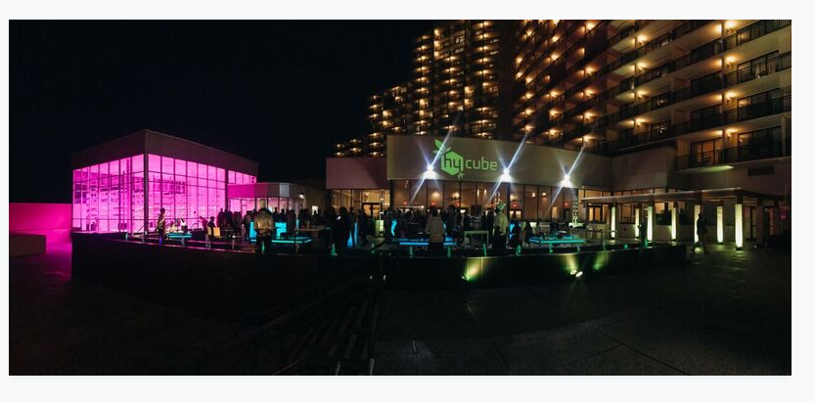 “We couldn’t be more excited about the addition of the hydroponic garden and continuing to work with Eco Convergence Group, whose local farms will supplement our onsite growing efforts,” said Ralph Scatena, General Manager at Orlando World Center Marriott. “Our chefs can rely on high-quality produce year-round to inspire new dishes and complement existing ones, while our guests will reap the benefits of our true ‘pick-to-plate’ practices through more vibrant colors, sharper flavors and crisper textures. Additionally, we have added function space with the Harvest Terrace, which will be an ideal location for [meetings and events](https://www.marriott.com/hotel-meetings/mcowc-orlando-world-center-marriott/modules/meetings/meeting-event-space.mi) of up to 250 attendees and could expand to as many as 750 by utilizing the terrace in conjunction with our newest restaurant, Latitude & Longitude, with the hydroponic garden as the backdrop, creating a truly unique experience.”

The HyCube’s glowing presence transforms a guest’s experience by enabling them to be more connected to the food they are eating and observe how their food is being grown, from seedling to fully-grown plants.

Orlando World Center Marriott is the first hotelier to utilize the revolutionary Hycube™ Hydroponic Production System.

**About Eco Convergence Group**

Eco Convergence Group, Inc. (ECG) is a fully owned subsidiary of Eco Convergence Group AS of Oslo, Norway and its United States headquarters is located in Orlando, Florida. ECG has developed the HyCubeTM, a patent-pending, data-driven, high-tech vertical hydroponic system that combines semiconductor industry-inspired environment control techniques with plant science to create perfect growing conditions resulting in produce with superior nutritional value, crispiness, consistency, and vibrancy. In HyCube’s highly controlled environment, produce coming from organic, non-GMO seeds grows contamination-free without the use of harmful pesticides, insecticides or fungicides. By eliminating outside climate factors this scientific approach results in high-yields and grow cycle reduction, without any seasonal restrictions on the offered product. HyCubes have a visually striking, modular, and extensible design using advanced energy-efficient construction approaches. They are deployed on or near customer premises for near zero food-miles and minimum storage requirements, such that HyCube-grown produce can be plated within hours of harvesting. ECG is currently working on a rollout of its HyCubes in the hospitality and food services industries in the United States and abroad. For more information please visit [www.ecghydro.com](http://www.ecghydro.com) or call Eco Convergence Group, Inc. at 1-406-574-8204.

**About Orlando World Center Marriott**

Towering above more than 200 prime, Central Florida acres, the world’s largest Marriott, Orlando World Center Marriott offers experiences that are a "World Beyond Compare.” Featuring everything on-premise from the iconic Falls Pool Oasis — ranked one of the “world’s coolest hotel pools” by Forbes — with a Slide Tower featuring two, 200 ft. winding waterslides and one, 90 ft. speed slide, in addition to a Splash Zone offering kids a zero entry pool and playground, as well as a Kid’s Activity Zone and Poolside Bar and Grill. Other on-property amenities include the 18-hole championship golf course, Jack Nicklaus Academy at Hawk’s Landing Golf Club, a full-service spa and fitness center, nine taste-tempting restaurants and lounges, as well as 450,000 sq. ft. of event space. In this magnificent locale, the 2,009-room resort is located only 1.5 miles from Walt Disney World® and just minutes from SeaWorld® Orlando, Discovery Cove®, AquaticaTM and Universal Studios®. For additional information please visit [www.worldcentermarriott.com](http://www.worldcentermarriott.com).

# # #