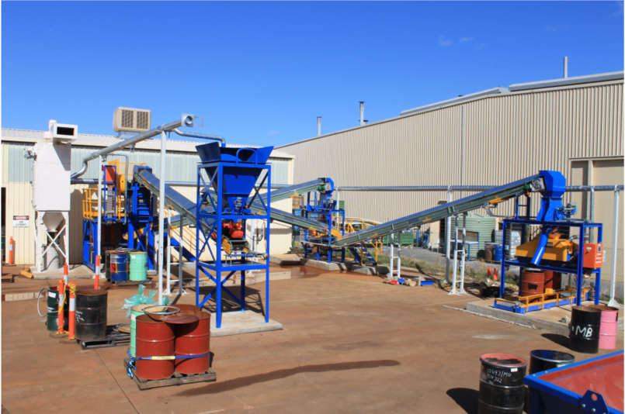
(Figure 1: Communition circuit of the SGS test plant. It is anticipated that 3-4 5-tonne bulk samples can be processed per week by this facility. Bulk sample test work will be overseen by the existing scrutineering regime ensuring sample integrity in a certified laboratory environment.)

