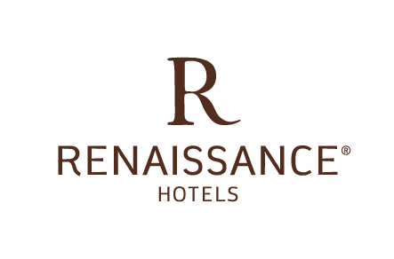
CONTACT: Renaissance Los Angeles Airport Hotel
9620 Airport Boulevard Los Angeles California 90045 USA
1-310-337-2800
http://www.marriott.com/hotels/travel/laxrr-renaissance-los-angeles-airport-hotel/

Renaissance Los Angeles Airport Hotel Unveils Its New Look
Hotel at LAX shows off new renovations and a dramatic new vibe

Los Angeles, California – August 11th, 2017 – Renaissance invites guests to go beyond the conventions of modern travel with the Los Angeles airport hotel’s unveiling of its dramatic new transformation. Following its recent renovations, the hotel offers completely new, renovated meeting spaces, a redesigned lobby and a brand new bar and restaurant.
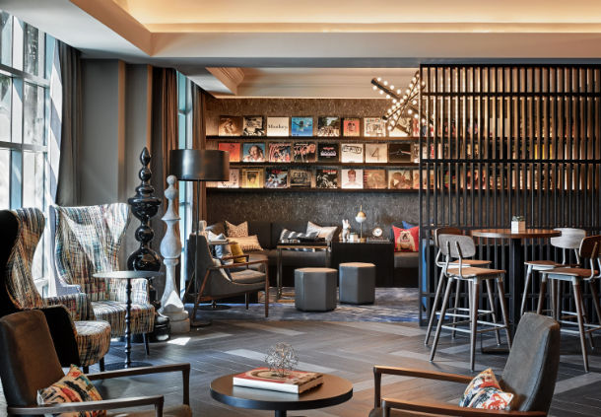
A captivating new arrival experience greets guests as they walk through the doors of this dynamic airport hotel. Mixing the personality of a boutique hotel with the urban style of LA, guests are greeted by a curated album wall and a neighborhood-inspired aesthetic that’s reflected in all aspects of the property’s refreshed design.

The hotel’s new restaurant, Studio 12, offers up delectable California cuisine and 12 beer taps featuring local craft brews. Designed to motivate and inspire, the menu at Studio 12 reflects the new style and vibe of the hotel, while sourcing its ingredients and inspirations from some of the area’s best local culinary regions.

For savvy travelers seeking an escape from the chaos of LAX and its large neighboring hotels, Renaissance Los Angeles Airport offers a more intimate alternative, blended with the feel of a trend-setting cosmopolitan studio.

Geared toward social discoverers and modern travelers, everything at the newly-renovated Renaissance Los Angeles Airport Hotel goes beyond the ordinary. The hotel’s unrivaled hospitality team provides a more personalized level of service and a glimpse at the true essence of L.A.

Through October 31st, Marriott Rewards members can earn 5,000 bonus points when their stay at the newly-renovated property includes a Sunday or Monday night. Book online at Marriott.com using code M11. For more information visit the hotel website, or follow the Renaissance Los Angeles Airport on Instagram at @renaissancelax or on Facebook at facebook.com/LAXRenaissance/

About Renaissance Los Angeles Airport Hotel

The Renaissance Los Angeles Airport Hotel is a starting point to discovering LA’s cosmopolitan vibe. Guests are invited to relax with a creative cocktail in the hotel’s totally redesigned lobby or catch a set from emerging local musicians. No matter travelers choose to explore, they find countless ways to captivate their curiosity at this stylish and eclectic hotel. Inside, guests enjoy a boutique hotel setting, the perfect contrast to Los Angeles’s fast-paced style. Travelers can sample indigenous flavors and local beers at the all-new, Studio 12. Or, step into the well-equipped fitness center before going for a dip into the exhilarating, outdoor pool. If planning to host a meeting or social event, there’s 18,000 square feet of newly-renovated, high-tech LAX event space that’s perfect for any occasion. When it’s time to head out to discover more, the hotel’s Navigators will show guests where to find the best-kept secrets, in and around town.

# # #

