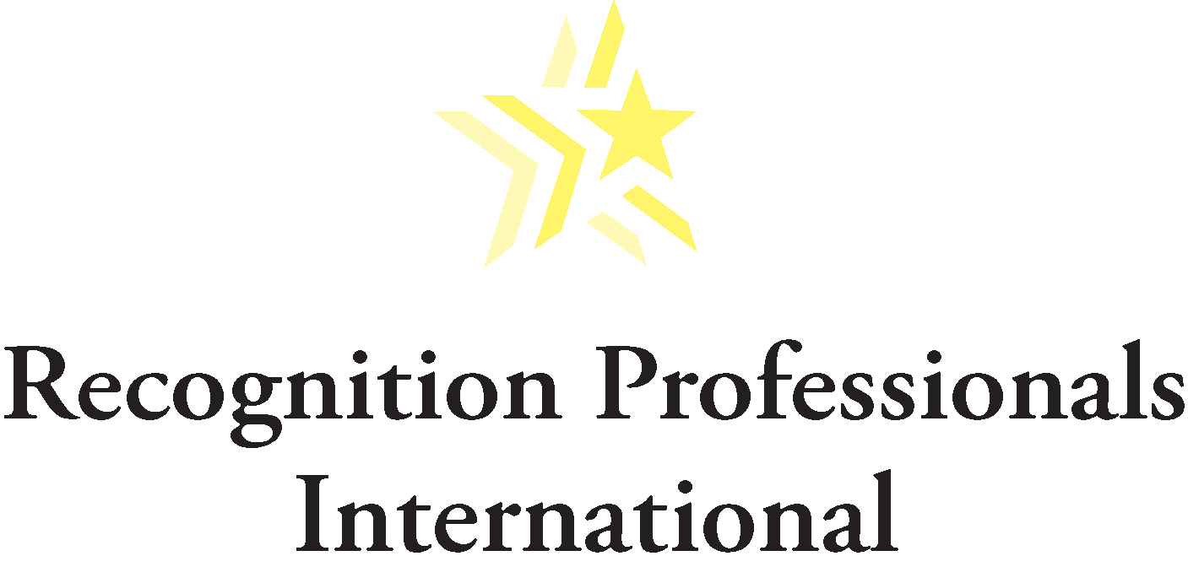

Contact Information:
Media
Jess Myers
651-290-7465 (o)
612-910-3058 (c)

Annual “Employee Appreciation Day” 2018 Celebrated March 2
International event launches year-round culture of employee recognition and rewards world-wide

ST. PAUL, Minn. (February 23, 2018) – Good employers make sure their workers know that they are recognized and valued. Great companies do so every day. That is the thinking behind the annual Employee Appreciation Day, which will be celebrated world-wide on March 2. It is a one-day celebration, designed to foster a 365-day attitude of recognition and rewards for the best employees.

“It is always enjoyable to see what fun, exciting and creative ways companies find to celebrate Recognition Day. It’s even more fun to see so many successful and world-renowned employers for whom Recognition Days is a way to kick-start a year-round culture of appreciation, making every day an occasion to recognize good work and encourage employees,” said Kathie Pugaczewski, executive director of Recognition Professionals International – a world-wide professional association at the forefront of workforce recognition. “Our member organizations always look at Employee Appreciation Day as a chance to be creative and spotlight the many efforts to recognize good work.”

With the economy growing, talented and dedicated workers remain more valuable than ever, which means the most successful employers large and small focus more time and resources toward employee recognition.

Recognition efforts range in scope from simple events like a root beer float bar at work all the way to elaborate incentives like travel and fiscal rewards. Successful companies routinely partake in these efforts, and the results are clear to see.

To achieve a sustainable culture of recognition and engagement, RPI has developed and tested the 7 Best Practice Standards® which are based on knowledge gained from academic literature, professional conferences and shared experiences in developing successful recognition programs. These standards have been amended periodically to reflect the lessons learned from previous program cycles, including suggestions from RPI Best Practice Standards® judges and award recipients. They are designed to be useful for the creation and evaluation of recognition programs in the public and private sectors, large and small organizations, and organizations with single or multiple locations or functions. RPI Best Practice Award winners include MIT, Southwest Airlines, RBC and Cleveland Clinic. For more information on the RPI 7 Best Practices, go here: http://www.recognition.org/?page=best_practice

Delivering positive employee experiences requires the right knowledge and skill set, which led to RPI creating the Certified Recognition Professional® (CRP) program. It consists of four courses (all online) designed to guide participants through the latest information and research on building a successful recognition program. Using our Best Practice model with seven strategic recognition categories ensures measurable results. More information here: http://www.recognition.org/page/CRP_Level_II_A

Ensuring employees feel valued has been shown to boost productivity and pay dividends for businesses and organizations. Detailed in a recent RPI webinar, among the many ideas that experts offer for employee recognition activities are food events, team activities, wellness efforts and other ideas, including:
- Create a workplace cookbook, with each employee contributing their favorite recipe, and each of them getting a “book” featuring all of the foods.
- Remember off-site and “virtual” employees and find ways to include them, so they feel as recognized and valued as on-site employees.
- Whatever you do, start small and build gradually, with more activities and edibles as the employee recognition culture grows within your organization.

For other webinars and a wealth of information on Recognition Day, please visit the RPI website at www.recognition.org. For interviews with employee recognition experts, please contact Jess Myers, 651-290-7465, jessm@ewald.com.

# # #

About RPI
Founded in 1998, Recognition Professionals International (RPI) is the only professional association at the forefront of workforce recognition through its sole focus on recognition innovations and education as a systematic method for improvements in the workplace. RPI is endorsed by top authorities in the industry, has an impressive membership of Fortune 500 organizations and is the only association offering Certified Recognition Professional® (CRP) courses.

