INITIAL GLOBAL ATOMIC DRILLING INTERSECTS HIGH GRADE and OFFSCALE URANIUM MINERALIZATION at its DASA PROJECT, REPUBLIC of NIGER

Toronto, ON, February 22, 2018: Global Atomic Corporation (“Global Atomic” or the “Company”), (TSX-V: GLO) is pleased to report initial gamma probe results from its current drill program at the DASA deposit (“DASA”) in the Republic of Niger, West Africa.

Drilling recommenced at DASA at the end of January, 2018, following the successful merger with zinc producer, Silvermet Inc. The Company, now known as Global Atomic Corporation trades on the Toronto Venture Exchange under the symbol “GLO” (TSX-V: GLO).

Global Atomic has begun a 30,000 meter drill program focused on defining an area suitable for open pit mining called the Flank Zone. This area of the DASA deposit is within the Tchirozerine 2 (T2) formation which outcrops and then dips into the graben where it becomes high grade when capped with a mudstone hanging wall unit called the Irhazer (IRH).

The first two holes drilled on the Flank Zone returned as follows:

Hole | From (meters) – To (meters) | Length (meters) | Grade (ppm / % U₃O₈)
ASDH 538  including  including | 163.2 – 258.4  199.1 – 200.5  240.1 – 253.1 | 95.2  1.4  13.0 | 4,442  27,720 (2.77% U₃O₈)  18,355 (1.83% U₃O₈)
ASDH 541  including  including | 240.3 – 284.6  243.4 – 252.5  267.3 – 269.5 | 44.3  9.1  2.2 | 6,682  11,116 (1.12% U₃O₈)  20,806 (2.08% U₃O₈)

The holes were drilled at an angle from hanging wall side of the graben to intersect the Flank Zone (see attached drawing).
3D Model : DASA Open Pit and Underground Resources Model With Planned Drilling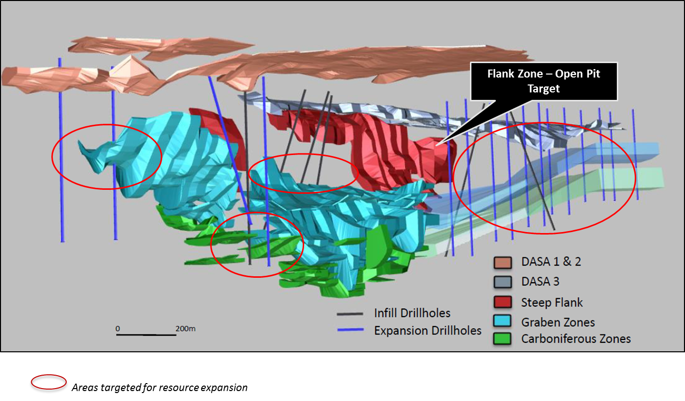

The first two holes have been completed and probed with a Gamma Probe. The probe measured significant mineralized intervals with wide “offscale” (plus 1%) sections in each hole. A “Gieger-Muller” (GM) probe was utilized over the offscale sections and a calculation estimate of grade is being reported in this press release prior to final grade determination through chemical assay.

Global Atomic will complete significant drilling in this area over the next six months in order to develop a mine plan and complete a technical report to support a mining operation intending to ship mineralized rock to ORANO (formerly knows as AREVA Mines), 80 kilometers north of the DASA Project under the Company’s Ore Sales Agreement.

QP Statement
Mr. George A. Flach, P.Geo., Vice President of Exploration, has reviewed this press release as the Qualified Person (QP) as defined in National Instrument 43-101.

About Global Atomic
Global Atomic is a TSX Venture listed company providing a unique combination of high grade uranium development and cash flowing zinc concentrate production. Global Atomic’s Uranium Division includes six exploration permits in the Republic of Niger covering an area of approximately 750 km². Uranium mineralization has been identified on each of the permits, with the most significant discovery being the DASA deposit situated on the Adrar Emoles III concession, discovered in 2010 by Global Atomic geologists through grassroots field exploration.

In a technical report dated July 31, 2017, Perth, Australia based CSA Global Pty Ltd (“CSA”) estimated the mineral resources for DASA as follows:

 | Tonnes  (millions) | U₃O₈  (ppm) | U₃O₈  (million lbs)
Indicated | 3.7 | 2,608 | 21.4
Inferred | 7.7 | 2,954 | 49.8

CSA estimated the mineral resource based on a cutoff grade of 1,200 ppm

Global Atomic’s Base Metals Division holds a 49% interest in the BST joint venture, operating a facility located in Iskenderun, Turkey that converts EAFD (Electric Arc Furnace Dust) into a high grade zinc oxide concentrate which is sold to zinc smelters around the world. The Company’s joint venture partner, Befesa Zinc S.A.U. (“Befesa”), holds a 51% interest in and is the operator of BST. Befesa is a market leader in EAFD recycling, capturing approximately 45% to 50% of European EAFD market with facilities located throughout Europe and Korea.

Our website has been updated! Please visit www.GlobalAtomicCorp.com for further information.
Key contacts:
Stephen G. Roman George A. Flach, P.Geo.
Chairman, President & CEO Vice President, Exploration
Tel: (416) 368-3949 Tel: (416) 368-3949
Email: sgr@globalatomiccorp.com Email: gaflach@globalatomiccorp.com

The information in this release may contain forward-looking information under applicable securities laws. This forward-looking information is subject to known and unknown risks, uncertainties and other factors that may cause actual results to differ materially from those implied by the forward-looking information. Factors that may cause actual results to vary include, but are not limited to, inaccurate assumptions concerning the exploration for and development of mineral deposits, political instability, currency fluctuations, unanticipated operational or technical difficulties, changes in laws or regulations, the risks of obtaining necessary licenses and permits, changes in general economic conditions or conditions in the financial markets and the inability to raise additional financing. Readers are cautioned not to place undue reliance on this forward-looking information. The Company does not assume the obligation to revise or update this forward-looking information after the date of this release or to revise such information to reflect the occurrence of future unanticipated events, except as may be required under applicable securities laws.

