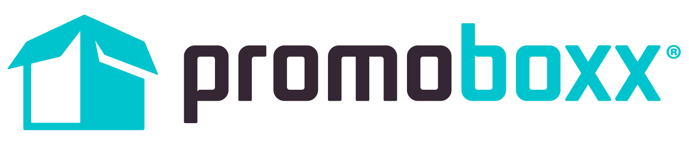
Promoboxx, Inc.
500 Harrison Avenue, Suite 3R
Boston, MA 02118
800.380.7502

Retail Marketing Experts Take the Stage at Promoboxx’s Aligned Conference
The Premier Event for Retail and Brand Marketers Returns to Boston in its Fourth Year to Drive the Future of Brand-to-Retailer Marketing

BOSTON, MA - August 22, 2017 - Promoboxx, the only brand-to-retailer commerce platform, today announced the agenda, keynotes, and sessions lineup for its annual industry event, Aligned. The Aligned Conference is the only event that brings together digital, trade, field, brand and retail marketers across all industries to share marketing strategies that increase local retail loyalty, mindshare, and the battle for revenue. For the fourth consecutive year, over 100 brand and retail marketing leaders from brands like GE Appliances, Nissan, and Arc’teryx will come together September 20-22 in Boston, MA at the Aloft Boston Seaport Hotel.
Aligned was created to address the gap that existed for an industry event where marketers at national manufacturing brands could meet up, regardless of industry, to discuss strategies for working with their local retail partners. This unique event fosters collaboration, discovery, and opportunities for attendees to discuss successes and challenges.

This year’s theme is Back to the Start: Why Your Independent Retail Channel Matters. With the recent headlines of big box store closures and the shifts happening in the retail environment, the sessions will focus on how brands can empower their local retail partners and keep their businesses thriving. The can’t-miss agenda features the conference keynote, “The Future of Local Commerce is Person to Person” which will be led by Ben Carcio, CEO and Co-Founder at Promoboxx, Gary Ambrosino, CEO at TimeTrade, and Ben Hindman, Founder and CEO at Splash.

“In less than one month, the brightest and most forward-thinking brand and retail marketers will come together at Aligned,” said Ben Carcio, CEO and Co-Founder at Promoboxx. “Promoboxx is thrilled to sponsor the Aligned Conference. This year’s agenda represents a diverse, multi-industry view of the retail marketing landscape. We look forward to bringing together speakers and attendees for a collaborative discussion of real-world solutions to the unique opportunities facing the retail marketing industry today.”

The 2017 agenda explores a wide range of topics on building the future of retail marketing:
- Why Retailer Enablement is Critical to Your Digital Marketing Strategy - Sheldon Bailey, Consumer Business Manager at ADM Animal Nutrition
- How To Strengthen Ties with Your Retailers - Marilyn Barefoot, Founder at Barefoot Brainstorming
- The Reasons Your Retailers Aren't Engaging (and How to Fix It) - Shelley Kanther, Digital Marketing Consultant at New England Appliance and Electronics Group
- Taking a Stand: Integrating Advocacy into your Marketing Campaigns - Josie Norris, Communications and Grant Program Manager at The Conservation Alliance
- How Video Marketing can Delight Customers and Increase Local Awareness - Todd Callaway, Director of Digital Content at Shaw Floors
- The Future of Retail Innovation: Promoboxx Product Roadmap - Joe Bracken, VP of Product at Promoboxx

The agenda will also feature a variety of panel sessions, including:
- The Future of Local Commerce is Person to Person
- 3 Things Your Sales Reps are Dying to Tell You
- How Retailers are Adapting to a Shifting Retail Environment

Aligned is designed to promote engagement and collaboration among attendees. The conference will include networking events, the Local Business of the Year award, and the Aligned Awards, which recognize the best digital marketing campaigns that connect a brand with its local retailers to drive sales.

To register for Aligned 2017 and view the full agenda, please visit www.alignedcon.com.
About Promoboxx

Promoboxx is the only brand-to-retailer commerce platform that connects and aligns national manufacturing brands with independent, speciality retailers to increase local awareness and sales. Founded in 2010 and headquartered in Boston, Massachusetts, Promoboxx partners with leading brands, including Nissan, GE Appliances, New Balance, and The North Face, to transform the way retailers and brands market together at a local level. For more information, visit www.promoboxx.com or call +1 (800) 380-7502 x3.

Promoboxx Media Contact:
Isolde Decker-Lucke
Promoboxx
isolde@promoboxx.com

