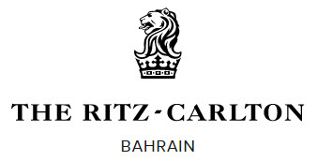
News
Contact: Amanda M. Williams Bldg. 112, King Mohammed VI Ave,
Assoc. Director of Public Relations Block 428, Al Seef District
Amanda.M.Williams@ritzcarlton.com Manama, Bahrain

+973 1758 6711 +973 175 80000

NEW PROPERTY ENHANCEMENTS UNVEILED AT
THE RITZ-CARLTON BAHRAIN
Over $1.5 million dollars invested in Bahrain luxury hotel, bringing a new European-designed marina and outdoor heated pool experience

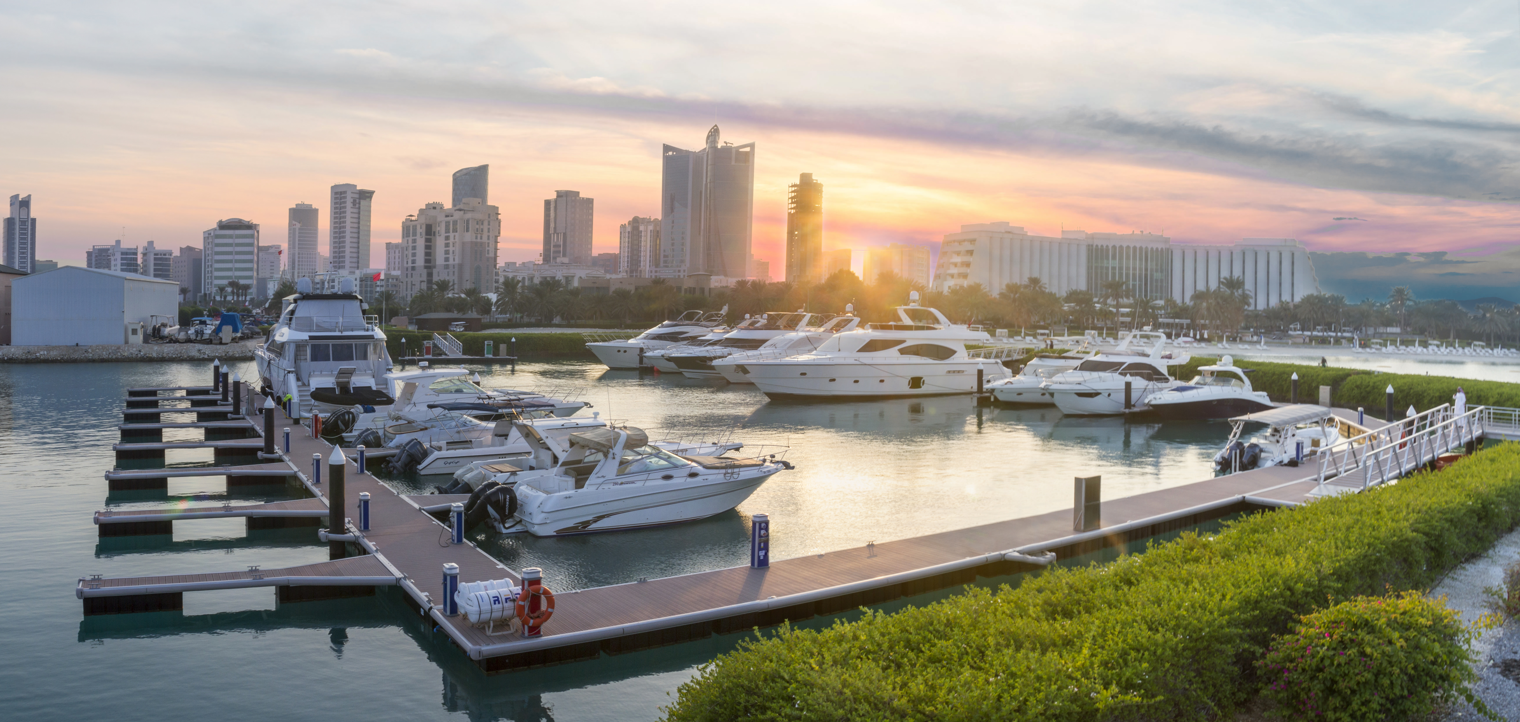
MANAMA, Bahrain – December 21, 2017 –As the new year arrives, The Ritz-Carlton, Bahrain unveils over $1.5 million dollars in property enhancements, including a revitalized marina and dock area and new outdoor heated pool experience this January. Since the opening in 2003, The Ritz-Carlton, Bahrain luxury resort has been committed to the revitalization of its 20-acre resort facilities year after year with the addition of new fine dining restaurants including Cantina Kahlo in October 2016 and this year with the major redevelopment being the Royal Beach Club marina facilities.

As the only marina in the North and West coast of the island Kingdom of Bahrain, the new marina enhancement, designed in partnership with United Marine Trading Co. (UMT), features a unique, state-of-the-art European design boasting the latest in nautical technologies, fueling facilities and life safety features. Sitting on its own private curved basin, the facility also adds ten new mooring spaces for boats with over half the area now exclusively reserved for larger luxury boats above 13 to 27 meters in size, along with an upgraded electrical capacity and high-quality pontoons to support the overall structure. One-of-a-kind touches also add to the design with metal cleat hooks that are embossed with The Ritz-Carlton brand logo and ambient deck lighting casting blue and white hues beneath the starry night sky.
Royal Beach Club Marina at The Ritz-Carlton, Bahrain

“Our new marina facilities are a testament to our commitment to quality. However, the larger vision is how we can always improve the overall resort experience for guests and valued Royal Beach Club members who have been a part of the resort’s journey for over 20 years, says Costas Christou, Director of Engineering. “This is what makes our brand stand out from the rest and what signifies our direction as we look to the future together with our ownership International Hotels Establishment.”

Advanced life safety features will also exalt a more secure environment with additional safety ladders, two fire hose reel cabinet and caddy units, high-pressure fire hydrants and lockable aluminum gates on each gangway. Arriving at the dock area, guests will also experience a more widened and extended pathway to the marina, along with smooth access bridges during low tides off the Arabian Gulf.

“Working on the Royal Beach Club marina project was an enriching experience for United Marine Trading Co. (UMT). And like with past large and mid-size marina projects across the GCC we’ve executed, this project also presented its challenges. However, we saw this as an opportunity to truly push the boundaries and deploy creative efforts to re-design the berth spaces to add more mooring facility for the addition of larger yachts.” says Bassam Hajj, General Manager for UMT.
Heading to the resort’s wet areas, guest will now be able to experience heated temperatures close to that of a traditional Turkish Hamman as the resort swimming pools see a complete update to their heating system. The new enhancement will ensure a year-round experience for visiting guests to relax and enjoy poolside even during the breezy-cool months of the Bahrain winter.

Open enrollment for the 2018 Royal Beach Club membership ends January 10, 2018. For additional information about The Ritz-Carlton, Bahrain, or to reserve your stay, please call (800) 00995, the hotel directly at (+973) 1758 0000, a travel professional or visit The Ritz-Carlton website at ritzcarlton.com/bahrain. Follow the hotel on Facebook and join the conversation using #RCMemories.
###
About The Ritz-Carlton, Bahrain
Set within 20 acres of lush gardens and golden sandy beaches on the Gulf of Arabia, the 245-room city resort is one of the most elegant destinations in Bahrain, and a place where guests can immerse themselves in the local culture, enjoy extraordinary cuisine and explore the dazzling capital city of Manama, adding yet another level of luxury to a collective range of extraordinary experiences. In addition to the Deluxe room categories, the resort also features 31 suites and 42 Club Level rooms as well as 23 well-appointed, seafront villas, each with three-bedrooms, its own private infinity pool, private beach access and 24-hour butler service.

Catering to the most discerning epicurean connoisseur, the resort offers both modern and international dining experiences with its seven award-winning restaurants, including: Catina Kahlo (Mexican), Nirvana (Indian), Plums (Steakhouse), La Plage (Beach cafe), Thai (Asian Fusion and Sushi), La Med (Mediterranean) and Primavera (Italian). For leisurely dining moments or for afternoon tea, The Lobby Lounge and The Ritz Gourmet offer guests à la carte café and dessert options, while both Burlington Club and Kahlo Club entertain a more sophisticated ambiance perfect for enjoying vintage spirits, premium cigars, modern cocktails (and mocktails) and light bites. In-room dining is also available to guests’ 24-hours a day.

A variety of guest amenities abound with outdoor and indoor swimming pools, an award-winning Ritz-Carlton Spa, Royal Beach Club, private marina, 24-hour fitness center, paddle boarding and kayaking rentals, Ritz Kids clubhouse, tennis and squash courts, business center, flamingo lagoon, Concierge desk with Les Clefs d'Or® Head Concierge, men’s and women’s hair salon, and shopping arcade with six luxury boutiques. In addition, the resort’s more than 18,000 square meters (19,000 square feet) of indoor and outdoor event spaces promise the perfect venue for any meeting or special occasion. For additional information about The Ritz-Carlton, Bahrain, please call please call (800) 00995, the hotel directly at (+973) 1758 0000, a travel professional or visit The Ritz-Carlton website at ritzcarlton.com/Bahrain.
About The Ritz-Carlton Hotel Company, LLC
The Ritz-Carlton Hotel Company, L.L.C., of Chevy Chase, MD., part of Marriott International, Inc., currently operates more than 90 hotels and 40 residential properties in more than 30 countries and territories. The Ritz-Carlton is proud to participate in the industry’s award-winning loyalty program, Marriott Rewards® which includes The Ritz-Carlton Rewards®. Members can now link accounts with Starwood Preferred Guest® at members.marriott.com for instant elite status matching and unlimited points transfer. For more information or reservations, visit the company web site at www.ritzcarlton.com, for the latest company updates, visit news.ritzcarlton.com and to join the live conversation, use #RCMemories and follow along on Facebook, Twitter, and Instagram. The Ritz-Carlton Hotel Company, L.L.C. is a wholly-owned subsidiary of Marriott International, Inc.

