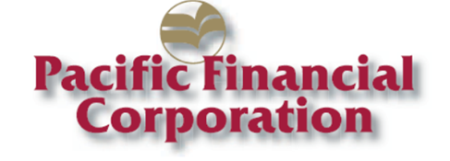
Contacts:
Denise Portmann, President & CEO
Douglas Biddle, EVP & CFO
Pacific Financial Corporation
360.537.4061

News Release

Pacific Financial Corporation Raises Annual Cash Dividend to $0.22 Per Share

ABERDEEN, WA -- December, 17, 2015 -- Pacific Financial Corporation (OTCQB:PFLC), the holding company for Bank of the Pacific, today announced that its Board of Directors declared a cash dividend of $0.22 per share to holders of common stock. The dividend will be payable on January 8, 2016, to shareholders of record on December 31, 2015.

"Our ability to increase our annual cash dividend by 5% is a testimony to the financial success we have achieved this year, and a reflection of the contribution our staff has made to further strengthen our banking franchise,” said Denise Portmann, President and Chief Executive Officer. “Cash dividends are one way to create shareholder value, and we appreciate the loyalty of our shareholder base.”

About Pacific Financial Corporation

Pacific Financial Corporation of Aberdeen, Washington, is the bank holding company for Bank of the Pacific, a state chartered and federally insured commercial bank. Bank of the Pacific offers banking products and services to small-to-medium sized businesses and professionals in Washington and Oregon. At September 30, 2015, the Company had total assets of $814.9 million and operated 17 branches in the communities of Grays Harbor, Pacific, Whatcom, Skagit, Clark and Wahkiakum counties in the State of Washington, and three branches in Clatsop County, Oregon. The Company also operates loan production offices in the communities of Dupont and Burlington in Washington. Visit the Company's website at www.bankofthepacific.com. Member FDIC.

Transmitted on Globe Newswire on December 17, 2015 at x:00 p.m. PST.

